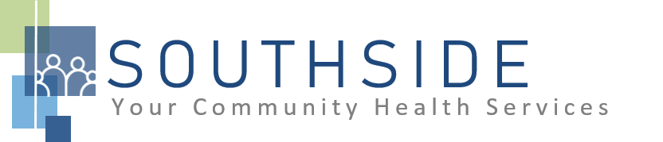
POSITION DESCRIPTION
JOB TITLE: Bilingual Licensed Therapist
REPORTS TO: Behavioral Health Director
STATUS: Exempt (salaried)
LOCATION: Hybrid- Medical, Dental and telehealth
SCHS is a 90-100 employee, full-service, non-profit healthcare clinic serving the needs of the South Minneapolis community. Come make a difference in the lives of people every day while helping us achieve our mission: To improve the health of our patients and communities by delivering exceptional care, removing barriers, and promoting healthy lifestyles.

ROLE: The licensed therapist oversees the treatment of patients with emotional, mental or psychological disorders. The Behavioral Health Therapist provides on-site and/or virtual therapeutic services.

JOB DUTIES:
- Facilitate individual and family sessions in an outpatient setting.
- Complete thorough diagnostic assessments.
- Develop treatment plan for patients.
- Ensure contract compliance. Initiate, implement and monitor compliance with evidence-based practices.
- Maintain complete, accurate, and timely records.
- Work with other members of the integrated health team to assure successful communication and coordination between all SCHS programs.
- Represent SCHS in a professional manner.
- Comply with behavioral health department policies and procedures.
- Understand and follow all policies and procedures of SCHS.
- Attend and participate in monthly clinical consultation meetings.
- Attend and participate in staff meetings and committees.
- Assist with other duties and responsibilities as assigned.

KNOWLEDGE, SKILLS, AND ABILITIES:
- Confidence, professional judgment, and grace under pressure.
- Excellent analytical, observational, critical thinking and decision-making skills required.
- High level of clinical knowledge for understanding what patients with depression, anxiety, addiction, bipolar, schizophrenia, or other disorders need from their treatment.
- Works well both independently and as part of a team.
- Patient, compassionate, and sympathetic.
- Commitment to maintain confidentiality.
- Strong written and oral communication skills.
- Ability to exhibit good rapport with clients of varying ethnic backgrounds and socio-economic status.
- Excellent time management and organizational skills.
- Attention to detail.
- Commitment to the SCHS mission and staff values.

MINIMUM QUALIFICATIONS:
- Licensed in discipline by appropriate state board (LPCC, LICSW, LMFT, LADC)
- Possess a strong community health/public health orientation.
- Experience and confidence in identifying and implementing evidence-based practices.
- Bilingual (English/Spanish)

Benefits:
*National Health Service Corps loan repayment option
• Healthcare (medical, dental, vision)
• Maternity and Parental Leave
• Company-paid Short-Term Disability -up to 8 weeks
• 403(b) savings plan
• Life Insurance at no cost to our employees
• Generous PTO
• Continued Education Reimbursement
• Employee assistance program
• Health savings account

