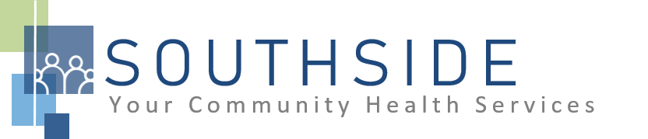
POSITION DESCRIPTION
JOB TITLE: Medical Interpreter
REPORTS TO: Medical Clinic Administrative Supervisor
STATUS: Non-exempt (hourly)
LOCATION: Medical/Dental/Vision Clinics
SCHS is a 90-100 employee, full-service, non-profit healthcare clinic serving the needs of the South Minneapolis community. Come make a difference in the lives of people every day while helping us achieve our mission: To improve the health of our patients and communities by delivering exceptional care, removing barriers, and promoting healthy lifestyles. Full COVID-19 vaccination is an essential requirement of this role. SCHS will obtain necessary proof of vaccination prior to employment to ensure compliance.

ROLE: This individual is responsible for listening to, understanding, and translating spoken or written statements from one language to another. In addition, they will reproduce statements in another language for unique listening or reading audience.
**THIS POSITION MAY WORK BETWEEN TWO CLINICS.
JOB DUTIES:
- Facilitate effective communication between patients, visitors and providers that do not speak a similar language by converting one spoken language to another.
- Participate in patient appointments and/or conferences and acts as official interpreter to mediate discussion.
- Relay concepts and ideas between languages.
- Facilitate communication for people with limited English proficiency.
- Interpret both clinical terminology and colloquial language.
- Translate materials from one language to another, communicating accurate meaning including cultural references, slang and other expressions that do not translate literally.
- Assist with other administrative duties as assigned.
- Attend and participate in staff meetings and committees.
- Assist with other duties and responsibilities as assigned.
KNOWLEDGE, SKILLS, AND ABILITIES:
- Confidence, professional judgment, and grace under pressure.
- Works well both independently and as part of a team.
- Excellent verbal and written communication skills.
- Flexibility and ability to respond to an evolving workload.
- Ability to exhibit good rapport with clients of varying ethnic backgrounds and socio-economic status.
- Comfort interacting with individuals with mental health symptoms.
- Excellent time management and organizational skills.
- Attention to detail.
- Commitment to the SCHS mission and staff values.

MINIMUM QUALIFICATIONS:
- Two years of interpreter experience, at least one year in a healthcare setting – 40 HOURS COMMUNITY CERTIFICATE REQUIRED.
- Bilingual (English/Spanish) required.
- Basic PC skills: MS Office.
- Reading and written fluency in both languages.

I have read and agree to abide by the job duties indicated above.
_______________________________ _______________________________ _________________
Name Signature Date

