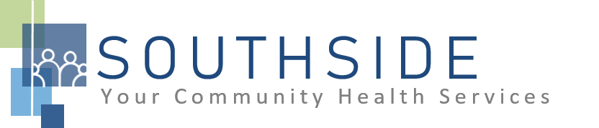

POSITION DESCRIPTION
JOB TITLE: Call Center Patient Care Representative – Bilingual (English/Spanish)
REPORTS TO: Call Center & PCR Optimization Specialist/EHR Analyst
STATUS: Non-exempt (hourly)
LOCATION: Call Center (Sabathani)
SCHS is a 90-100 employee, full-service, non-profit healthcare clinic serving the needs of the South Minneapolis community. Come make a difference in the lives of people every day while helping us achieve our mission: To improve the health of our patients and communities by delivering exceptional care, removing barriers, and promoting healthy lifestyles.

ROLE: This position exists to ensure efficient patient flow and excellent customer service; answers multi-line telephone and directs calls as appropriate. Answers incoming calls to schedule appointments for medical/dental/vision services and/or take complete and accurate messages. Interacting with patients via telephone and performs a range of duties which includes gathering required information in preparation for the patient's appointment.
JOB DUTIES:
- Answer the telephone during clinic hours; provide information or take complete and accurate messages as appropriate.
- Manage calls effectively and efficiently; assure patient flow is moving at required pace. Able to identify patient needs to ensure appropriate scheduling of appointments.
- Providing empathetic and compassionate service that leaves a good impression.
- Schedule medical/dental/vision appointments.
- Collect all required patient demographic information during scheduling.
- Determine if patient has existing insurance coverage; discuss payment options and schedule appointment with patient advocate, if necessary.
- Help patients resolve balances or set up payment plans when appropriate.
- Send mConsent form links for patients missing consent forms after scheduling an appointment.
- Answer voicemails, emails, in-basket messages, Epic bubbles and/or other requests from patients and/or healthcare providers while meeting or exceeding service level goals.
- Supports departmental changes, demonstrating flexibility and a positive attitude in a fast-paced, changing environment.
- Complete assigned administrative daily tasks between calls.
- Maintain a cancellation list and fill appointment openings.
- Attend and participate in staff meetings and committees.
- Assist with other duties and responsibilities as assigned.
KNOWLEDGE, SKILLS, AND ABILITIES:
- Confidence, professional judgment, and grace under pressure.
- Works well both independently and as part of a team.
- Exceptional communication skills.
- Flexibility--nimble in response to an evolving workload.
- Ability to exhibit good rapport with clients of varying ethnic backgrounds and socio-economic status.
- Excellent time management and organizational skills.
- Attention to detail.
- Commitment to the SCHS mission and staff values.

MINIMUM QUALIFICATIONS:
- Training as a receptionist and experience in scheduling medical or dental appointments preferred.
- Good computer and typing skills.
- Bilingual (English/Spanish) proficiency required.

I have read and agree to abide by the job duties indicated above.

Name ____________________________ Signature ________________________________________
Date ___________________

